SIMATS ENGINEERING
ASSESSMENT TOOL 3

COURSE NAME: Database Management Systems NAME: K. SARANYA
COURSE CODE: CSA0501 REG NO:192424409

COURSE OUTCOME COVERED

CO2: Apply the relational model, relational algebra, SQL query structures, and views to solve database querying and data manipulation problems. (BL3, BL6)

Activity Tool : Debugging & Optimisation Task (Low)
Assessment Tool Weightage: 30%

Dr

QUESTIONS Total Marks: 50
Q.No | Question | Bloom's Level | Marks
1 | Identify and fix the error in the given SQL query that uses incorrect JOIN syntax and returns duplicate results. | BL3 – Apply | 5
2 | The following sub-query returns incorrect results due to a missing correlation. Debug and rewrite it correctly. | BL3 – Apply | 5
3 | A given SQL view definition causes errors when queried. Identify the issue and rewrite a correct and optimized view. | BL3 – Apply | 5
4 | Debug the given relational algebra expression that produces incorrect output for a natural join operation. | BL3 – Apply | 5
5 | The SQL query below violates referential integrity. Identify the violation and modify the statements to enforce proper constraints. | BL3 – Apply | 5
6 | Given an inefficient SQL query with nested loops, rewrite it using JOIN to optimize performance. | BL6 – Create | 5
7 | The GROUP BY query below produces wrong aggregation results. Debug the query and explain the error. | BL3 – Apply | 5
8 | Identify and fix the logical error in a given SQL UPDATE statement that unintentionally modifies all rows in the table. | BL3 – Apply | 5
9 | Optimize the given multi-table SQL query by restructuring sub-queries into JOINs and using appropriate indexes. | BL6 – Create | 5
10 | Debug a given relational calculus expression that returns an empty result set due to incorrect quantifier usage. | BL3 – Apply | 5

Code of Conduct:

I K.SARANYA(1924244409 (Name / Reg No) certify that this submission is my original work and that I have adhered to the guidelines specified for this assessment.
I understand that any violation of academic integrity rules will result in disciplinary action.

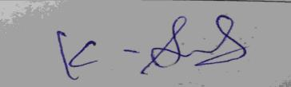
Signature of the student:

RUBRICS FOR CALCULATION:

Criteria | Weightage | Level 4 (Exemplary) | Level 3 (Proficient) | Level 2 (Developing) | Level 1 (Beginning)
Problem Identification | 20% | Accurately identifies all errors and root causes with clear understanding | Identifies most errors with minor gaps | Identifies some errors but misses key issues | Unable to identify errors correctly
Debugging | 25% | Applies systematic debugging techniques effectively to resolve issues | Uses appropriate debugging methods with minor errors | Limited debugging approach; requires guidance | Unable to debug or resolve issues
Optimization | 20% | Optimizes code by significantly improving time complexity using efficient algorithms | Improves time complexity with minor gaps in efficiency | Limited improvement in time complexity | No improvement; inefficient approach retained
Analysis | 20% | Demonstrates strong logical reasoning and clear justification of solutions | Shows reasonable analysis with some justification | Limited analysis; weak reasoning | No analytical reasoning demonstrated
Code Quality | 15% | Produces clean, well-structured code with proper comments and documentation | Code is mostly clear with minor documentation gaps | Code lacks structure and proper documentation | Poorly written code with no documentation

Q1. Incorrect JOIN Syntax Causing Duplicate Results

Problem
A query meant to list each order with its customer name instead returns the same order repeated multiple times.

Given Query (Incorrect)
SELECT o.order_id, c.customer_name, o.total_amount
FROM Orders o, Customers c, OrderDetails d
WHERE o.customer_id = c.customer_id;

Root Cause
The old-style comma join lists three tables (Orders, Customers, OrderDetails) but only supplies a join condition for two of them. OrderDetails is left completely unrestricted, so SQL performs an implicit CROSS JOIN between Orders/Customers and every row of OrderDetails — producing one duplicate row per line item instead of one row per order.
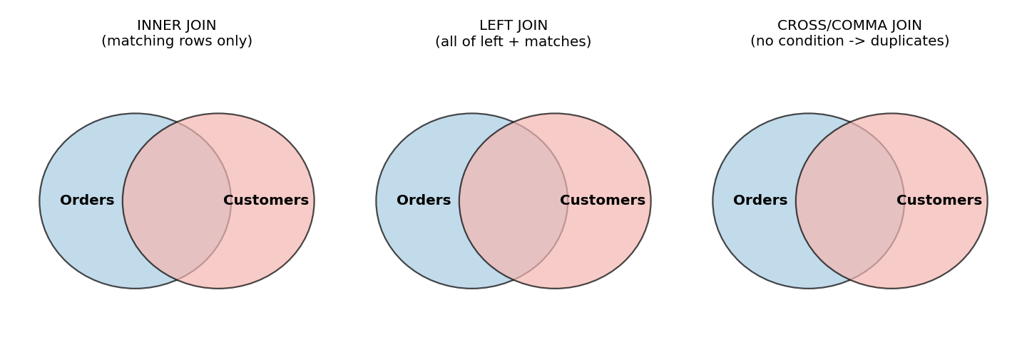
Figure 1.1 — INNER JOIN vs. an unconditioned comma/cross join that fans out into duplicates.

Corrected Query
SELECT o.order_id, c.customer_name, o.total_amount
FROM Orders o
INNER JOIN Customers c ON o.customer_id = c.customer_id;
-- OrderDetails removed because it is not needed for this result set.
-- If line-item data IS required, aggregate it first:
SELECT o.order_id, c.customer_name, o.total_amount, SUM(d.quantity) AS total_items
FROM Orders o
INNER JOIN Customers c ON o.customer_id = c.customer_id
INNER JOIN OrderDetails d ON o.order_id = d.order_id
GROUP BY o.order_id, c.customer_name, o.total_amount;

Explanation
- Always use explicit JOIN ... ON syntax rather than comma joins — it forces every join condition to be stated.
- Every table referenced in FROM must have a matching join predicate, or it silently becomes a Cartesian product.
- When a genuinely one-to-many relationship (Orders → OrderDetails) is involved, aggregate with GROUP BY instead of returning raw duplicated rows.

Q2. Sub-query With a Missing Correlation

Problem
A query intended to find employees who earn more than the average salary of their own department returns employees compared against the company-wide average instead.

Given Query (Incorrect)
SELECT e1.employee_id, e1.name, e1.department_id, e1.salary
FROM Employee e1
WHERE e1.salary > (
SELECT AVG(e2.salary)
FROM Employee e2
);

Root Cause
The inner sub-query computes AVG(salary) over the entire Employee table because it never references the outer row (e1). It is a simple, uncorrelated sub-query, so the same single average is compared against every employee, ignoring department boundaries.

Corrected Query
SELECT e1.employee_id, e1.name, e1.department_id, e1.salary
FROM Employee e1
WHERE e1.salary > (
SELECT AVG(e2.salary)
FROM Employee e2
WHERE e2.department_id = e1.department_id -- correlation added
);

Comparison
Aspect | Uncorrelated (Wrong) | Correlated (Fixed)
Average computed | One global average for all rows | One average per department
Inner query re-evaluated? | Once, cached | Once per outer row (per department value)
Result correctness | Compares apples to the whole orchard | Compares each employee to peers in the same department

Q3. Faulty View Definition

Problem
A view built to show department-wise total salary throws an error (or, in engines that tolerate it, returns non-deterministic values) whenever it is queried.

Given View (Incorrect)
CREATE VIEW DeptSalarySummary AS
SELECT department_id, employee_name, SUM(salary) AS total_salary
FROM Employee
GROUP BY department_id;

Root Cause
employee_name is selected but is neither wrapped in an aggregate function nor included in GROUP BY. Standard SQL rejects this outright ("not a GROUP BY expression"); engines that allow it (older MySQL) return an arbitrary, unpredictable employee_name for each group — a classic functional-dependency violation.

Corrected & Optimized View
CREATE VIEW DeptSalarySummary AS
SELECT d.department_id,
d.department_name,
COUNT(e.employee_id) AS employee_count,
SUM(e.salary) AS total_salary,
AVG(e.salary) AS avg_salary
FROM Department d
LEFT JOIN Employee e ON e.department_id = d.department_id
GROUP BY d.department_id, d.department_name;

-- Supporting index for the join/group:
CREATE INDEX idx_employee_department ON Employee(department_id);

Why this is optimized
- Only columns that are either grouped or aggregated appear in SELECT — no ambiguity.
- LEFT JOIN from Department keeps departments with zero employees visible (COUNT = 0) instead of silently dropping them, as an INNER JOIN would.
- An index on Employee.department_id lets the engine use an index scan/aggregate instead of a full table scan for the GROUP BY.

Q4. Relational Algebra Natural Join Producing Wrong Output

Problem
A natural join between Employee and Department is supposed to attach each employee's department name, but returns an empty or incorrect relation.

Given Expression (Incorrect)
Employee(emp_id, name, dept_no, salary)
Department(dept_id, dept_name, location)

π(name, dept_name) ( Employee ⋈ Department )

Root Cause
Natural join (⋈) matches automatically on attributes that share the same name in both relations. Here the common concept is named dept_no in Employee but dept_id in Department — the attribute names never actually match, so the natural join finds no common column, degenerating into a Cartesian product (or an empty result, depending on the engine's handling).
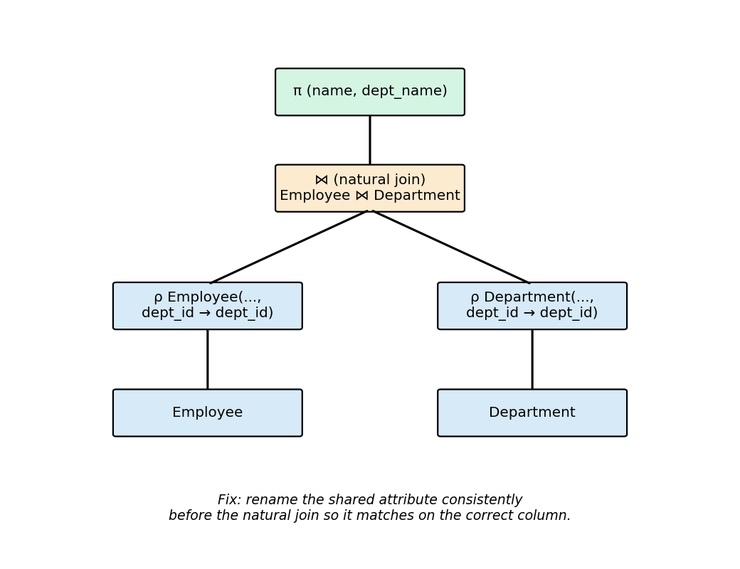
Figure 4.1 — Renaming (ρ) the shared attribute so the natural join can match correctly.

Corrected Expression
-- Rename dept_no to dept_id so both relations share the join attribute
ρ Employee'(emp_id, name, dept_id, salary) ( Employee )

π(name, dept_name) ( Employee' ⋈ Department )

-- Equivalent SQL:
SELECT e.name, d.dept_name
FROM Employee e
JOIN Department d ON e.dept_no = d.dept_id;

Explanation
- Natural join is name-driven, not meaning-driven — mismatched attribute names must be reconciled with the rename operator ρ first.
- In practice, an explicit theta-join (⋈ on a stated predicate) is safer than relying on natural join when schemas use different key names.

Q5. Referential Integrity Violation

Problem
Inserting a new order fails silently in application logic / corrupts reporting because it references a customer that does not exist, and deleting a customer leaves orphaned orders behind.

Given Statements (Incorrect)
CREATE TABLE Orders (
order_id INT PRIMARY KEY,
customer_id INT, -- no FK constraint
order_date DATE,
total_amount DECIMAL(10,2)
);

INSERT INTO Orders VALUES (5001, 9999, '2026-01-15', 250.00); -- customer 9999 doesn't exist
DELETE FROM Customers WHERE customer_id = 105; -- orders for 105 become orphans

Violation
Without a FOREIGN KEY constraint, the database has no way to reject an Orders.customer_id value that doesn't exist in Customers, and no defined behavior for what should happen to child rows when the parent is deleted. Both statements above corrupt referential integrity.
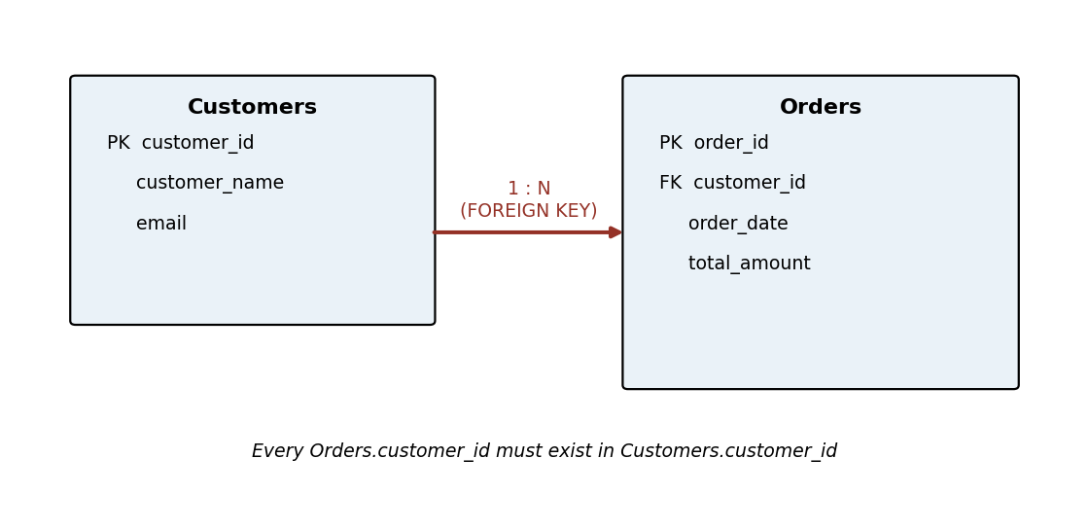
Figure 5.1 — Enforced parent/child (Customers → Orders) relationship via FOREIGN KEY.

Corrected Schema
CREATE TABLE Orders (
order_id INT PRIMARY KEY,
customer_id INT NOT NULL,
order_date DATE,
total_amount DECIMAL(10,2),
CONSTRAINT fk_orders_customer
FOREIGN KEY (customer_id) REFERENCES Customers(customer_id)
ON DELETE RESTRICT
ON UPDATE CASCADE
);

-- Now the following statements are correctly rejected / handled by the engine:
INSERT INTO Orders VALUES (5001, 9999, '2026-01-15', 250.00);
-- ERROR: insert violates foreign key constraint fk_orders_customer

DELETE FROM Customers WHERE customer_id = 105;
-- ERROR: update or delete violates foreign key constraint (orders still reference 105)
-- Either delete/reassign the child orders first, or use ON DELETE CASCADE
-- deliberately if orphaned orders should be removed automatically.

Constraint Options
ON DELETE Option | Behaviour when parent row is deleted
RESTRICT / NO ACTION | Delete is blocked while child rows still reference the parent (safest default)
CASCADE | All matching child rows are deleted automatically
SET NULL | customer_id in child rows is set to NULL (column must allow NULL)

Q6. Inefficient Nested Sub-query Rewritten as JOIN

Problem
A report listing customers who have placed at least one order runs a correlated sub-query per row, effectively re-scanning Orders once for every customer — very slow on large tables.

Given Query (Inefficient)
SELECT c.customer_id, c.customer_name
FROM Customers c
WHERE EXISTS (
SELECT 1 FROM Orders o
WHERE o.customer_id = c.customer_id
AND o.order_date > '2025-01-01'
)
-- ...but elsewhere in the report, similar logic is repeated as a nested
-- loop for total spend, e.g. inside application code calling the DB
-- once per customer instead of a single set-based query.

Optimized JOIN-Based Rewrite
SELECT c.customer_id, c.customer_name,
COUNT(o.order_id) AS order_count,
COALESCE(SUM(o.total_amount), 0) AS total_spend
FROM Customers c
INNER JOIN Orders o
ON o.customer_id = c.customer_id
AND o.order_date > '2025-01-01'
GROUP BY c.customer_id, c.customer_name;

-- Supporting index:
CREATE INDEX idx_orders_customer_date ON Orders(customer_id, order_date);
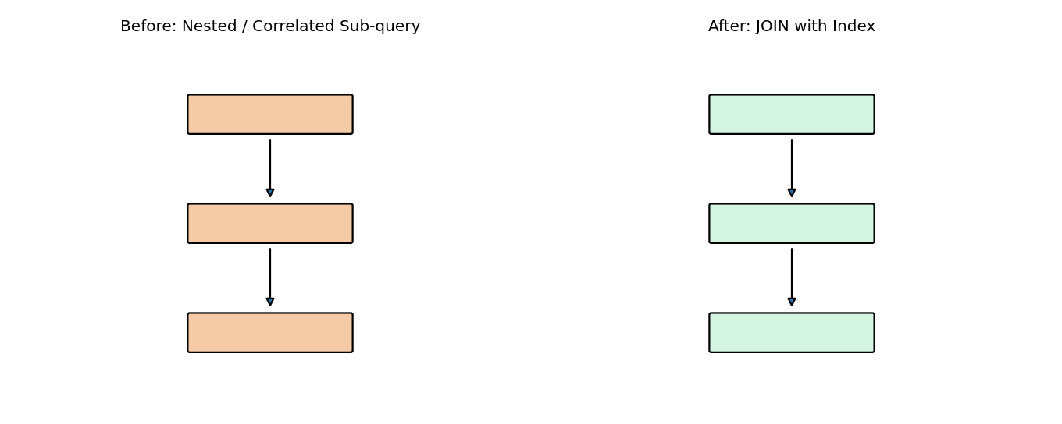
Figure 6.1 — Correlated sub-query re-scanning per row vs. a single indexed JOIN pass.

Why it's faster
- A single set-based JOIN lets the optimizer use one index scan/merge instead of N separate sub-query executions.
- Moving repeated per-row application-level lookups into one SQL statement removes N network round-trips (classic "N+1 query" problem).
- The composite index (customer_id, order_date) covers both the join key and the filter in one lookup.

Q7. GROUP BY Producing Wrong Aggregation Results

Problem
A monthly sales summary is supposed to total sales per product per month, but the numbers don't match manual calculations — some months appear merged together.

Given Query (Incorrect)
SELECT product_id, SUM(amount) AS monthly_total, sale_date
FROM Sales
GROUP BY product_id;

Root Cause
The grouping is only by product_id, so SUM(amount) aggregates every sale for that product across all months into one number — the per-month breakdown is lost. sale_date is also selected without being grouped or aggregated, so the value shown for it is arbitrary.

Corrected Query
SELECT product_id,
DATE_TRUNC('month', sale_date) AS sale_month,
SUM(amount) AS monthly_total
FROM Sales
GROUP BY product_id, DATE_TRUNC('month', sale_date)
ORDER BY product_id, sale_month;

Before vs. After
 | Given Query | Corrected Query
GROUP BY columns | product_id only | product_id + sale month
sale_date column | Non-grouped, arbitrary value | Replaced by a proper grouped month expression
Result granularity | One row per product (all months merged) | One row per product, per month

Q8. UPDATE Statement Unintentionally Modifying All Rows

Problem
A statement meant to give a 10% raise to a single employee ends up giving every employee in the table a raise.

Given Statement (Incorrect)
UPDATE Employee
SET salary = salary * 1.10;
-- WHERE employee_id = 204; <-- condition was commented out / forgotten

Root Cause
SQL's UPDATE has no implicit row scope — omitting or commenting out the WHERE clause applies the SET expression to every row in the table. There is no syntax error, so the mistake is only visible in the (wrong) data afterward.

Corrected & Safer Statement
-- 1. Always preview first:
SELECT employee_id, salary, salary * 1.10 AS new_salary
FROM Employee
WHERE employee_id = 204;

-- 2. Wrap the actual change in a transaction:
BEGIN TRANSACTION;

UPDATE Employee
SET salary = salary * 1.10
WHERE employee_id = 204;

-- 3. Verify the affected row count matches expectations, then:
COMMIT; -- or ROLLBACK; if the row count looks wrong

Preventive Practices
- Never omit WHERE on UPDATE/DELETE; if truly all rows should change, write WHERE 1=1 to signal it was intentional.
- Run the equivalent SELECT with the same WHERE clause first to confirm the target row set.
- Wrap risky statements in a transaction so a mistaken row count can be rolled back before COMMIT.
- Enable a SQL client's "safe update mode" where available, which blocks UPDATE/DELETE without a key-based WHERE.

Q9. Optimizing a Multi-Table Query: Sub-queries → JOINs + Indexes

Problem
A report that lists each customer with their total number of orders and total payment amount uses two separate correlated sub-queries per customer row, which does not scale as tables grow.

Given Query (Unoptimized)
SELECT c.customer_id, c.customer_name,
(SELECT COUNT(*) FROM Orders o WHERE o.customer_id = c.customer_id) AS order_count,
(SELECT SUM(p.amount) FROM Payments p
WHERE p.order_id IN (SELECT order_id FROM Orders o2 WHERE o2.customer_id = c.customer_id)
) AS total_paid
FROM Customers c;

Restructured Query Using JOINs
SELECT c.customer_id, c.customer_name,
COUNT(DISTINCT o.order_id) AS order_count,
COALESCE(SUM(p.amount), 0) AS total_paid
FROM Customers c
LEFT JOIN Orders o ON o.customer_id = c.customer_id
LEFT JOIN Payments p ON p.order_id = o.order_id
GROUP BY c.customer_id, c.customer_name;

-- Recommended indexes:
CREATE INDEX idx_orders_customer ON Orders(customer_id);
CREATE INDEX idx_payments_order ON Payments(order_id);

Performance Comparison
Metric | Sub-query version | JOIN + Index version
Orders table scans | Once per customer (N times) | Once total
Payments table scans | Once per customer via nested IN | Once total
Typical complexity | O(N × M) | O(N + M) with index support
DISTINCT needed? | No (scalar sub-queries) | Yes, on order_id, since the LEFT JOIN to Payments can multiply order rows

Q10. Relational Calculus With Incorrect Quantifier Usage

Problem
A domain relational calculus expression meant to find every supplier who supplies ALL parts returns an empty result set, even though such suppliers exist in the data.

Given Expression (Incorrect)
{ s.sname | Supplier(s) ∧
(∀ p) ( Part(p) ∧ (∃ sp) ( Supplies(sp) ∧ sp.sid = s.sid ∧ sp.pid = p.pid ) ) }

Root Cause
The universal quantifier ∀p is applied to the conjunction Part(p) ∧ (...). Read literally this demands that EVERY value p in the universe satisfies both "p is a part" AND "s supplies p" — which is false the moment any p exists that is not a part at all (e.g. a customer or a supplier tuple), collapsing the whole quantified expression to false for every s and returning an empty set.

Corrected Expression
{ s.sname | Supplier(s) ∧
(∀ p) ( Part(p) ⇒ (∃ sp) ( Supplies(sp) ∧ sp.sid = s.sid ∧ sp.pid = p.pid ) ) }

-- Equivalent SQL (division-style query):
SELECT s.sname
FROM Supplier s
WHERE NOT EXISTS (
SELECT p.pid FROM Part p
WHERE NOT EXISTS (
SELECT 1 FROM Supplies sp
WHERE sp.sid = s.sid AND sp.pid = p.pid
)
);

Why the Fix Works
Form | Meaning for each candidate part p | Result
∀p ( Part(p) ∧ Supplies(s,p) ) | p must be a part AND s must supply it — fails for any p outside Part | Always false → empty set
∀p ( Part(p) ⇒ Supplies(s,p) ) | IF p is a part, THEN s must supply it — vacuously true for non-parts | Correctly true only for suppliers covering all parts
The rule of thumb: a universally quantified statement over an unrestricted domain must use implication (⇒) to restrict the quantifier, not a plain conjunction (∧), otherwise it is falsified by irrelevant elements of the universe.

